**CHAPTER III**

**RESEARCH METHODOLOGY AND DESIGN**

This chapter described the methodologies used by the researchers to carry out the study. Methodology is a guiding approach for solving a problem, with specific components such as phases, tasks, methods, techniques and tools.

## 

## **Environment**

### **Setting of the study**

The study was conducted at Friendly Mart, Polomolok, South Cotabato.

**Project Development**

The following materials were utilized on the development of the study of Friendly Mart Ordering and Delivery Navigation with SMS Notification and Chatting System.

**Software Development Methodology**

Sprint Development – The Agile Model was chosen as the initial methodology for developing the Friendly Mart Ordering and Delivery Navigation with SMS Notification and Chatting System as its stages fit its development requirements

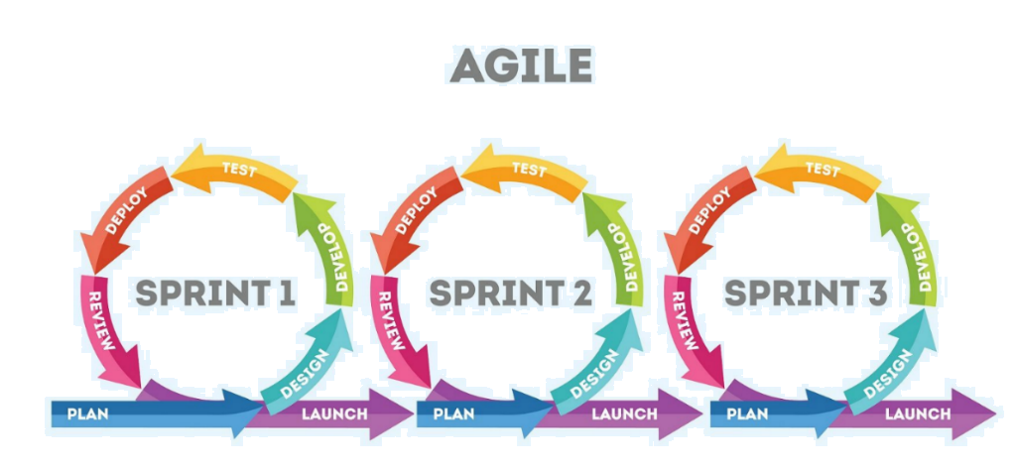

*Figure 3.1 Sprint Model of Agile Methodology*

The researchers identified the problem and determined that it required various features to enhance the automated desktop system. They created a project title and formulated the objectives, scope, and schedule for the project.

Additionally, the researchers recognized and addressed the challenges involved in designing and developing the Friendly Mart Ordering and Delivery Navigation with SMS Notification and Chatting System.

***Sprint 1. (Develop a system module that provides an intuitive and easy-to-navigate online catalog for customers.)***

The goal of Sprint 1 is to develop a system module that provides an intuitive and easy-to-navigate online catalog for customers, addressing the need for comprehensive online browsing and user-friendly within the system. This involves designing and implementing a module that captures and securely logs user actions, eliminating the inefficiencies associated with manual oversight. By providing the online catalog, the system will enable quicker browsing products catalog, thereby enhancing user-friendly and browsing.

One challenge in this sprint will be ensuring that the navigate online catalog accurately reflects user behavior while maintaining data security and privacy. This will require developing robust logging mechanisms and protocols for data access to prevent unauthorized actions. Additionally, the team must balance the need for comprehensive online catalog with user experience, ensuring that the system remains user-friendly and does not hinder workflow.

By the end of Sprint 1, the module should effectively navigate online catalog user activities, providing detailed logs that enhance accountability and reduce the risk of unauthorized actions.

***Sprint 2. (Develop a system module that automates real-time tracking of customer orders, providing comprehensive monitoring of order status from placement to delivery.)***

The objective of Sprint 2 is to implement systems that ensure accurate data logs and prevent duplication, addressing the issues of double entries and data inconsistencies. By developing this module, the system will automatically track the customer’s orders during input process, reducing errors that arise from manual entry.

This sprint will focus on ensuring that data collected by the system is consistently accurate. The system will track real-time of customers’ orders and flag inconsistencies, ensuring that the orders information remains reliable and real-time.

By the end of Sprint 2, the system will guarantee more accurate and reliable data real-time tracking orders, minimizing the issues caused by human error and improving overall quality.

***Sprint 3. (Develop a system module that enables seamless communication between customer and delivery personnel.)***

This module addresses the current challenges of delayed or untraceable communication, ensuring that messages related to orders, inquiries, or delivery updates are sent and received in real-time.

The module will securely log all conversations, providing a traceable communication history for both customers and delivery personnel. This ensures accountability, improves customer support, and allows administrators to monitor interactions when necessary.

By the end of Sprint 3, the system will provide a fully functional chatting system that enables efficient, real-time communication, helping to resolve order-related issues promptly and improving the overall user experience for both customers and delivery personnel.

***Sprint 4 (Develop a system module that automatically sends SMS notifications to customers regarding order confirmations, updates, and delivery status.)***

In Sprint 4, the focus is on developing a system module that automatically sends SMS notifications to customers regarding order confirmations, updates, and delivery status. This feature ensures that customers are informed in real-time about the progress of their orders, improving communication and reducing missed updates.

The module will automatically generate messages based on specific order events, such as order placement, payment confirmation, dispatch, and delivery completion. This automation reduces the need for manual notifications by staff, allowing them to focus on other operational tasks while maintaining consistent communication with customers.

By the end of Sprint 4, the system will be capable of automated SMS notifications, ensuring timely updates, improved customer satisfaction, and more efficient order management.

***Sprint 5 (Develop a system module that provides real-time delivery navigation for riders, ensuring accurate and efficient routes.)***

Sprint 5 will focus on developing a system module that provides real-time delivery navigation for riders, ensuring accurate and efficient delivery routes. This module will help riders optimize their routes, reduce delays, and improve the overall efficiency of the delivery process.

The system will track the real-time location of riders, provide step-by-step navigation guidance, and update order delivery statuses automatically. This ensures that both customers and administrators have access to accurate delivery information at all times.

By the end of Sprint 5, the system will be capable of real-time delivery tracking and navigation, improving delivery efficiency, reducing errors, and enhancing customer satisfaction.

**Planning/Conception-Initiation Phase**

**Business Model Canvas**

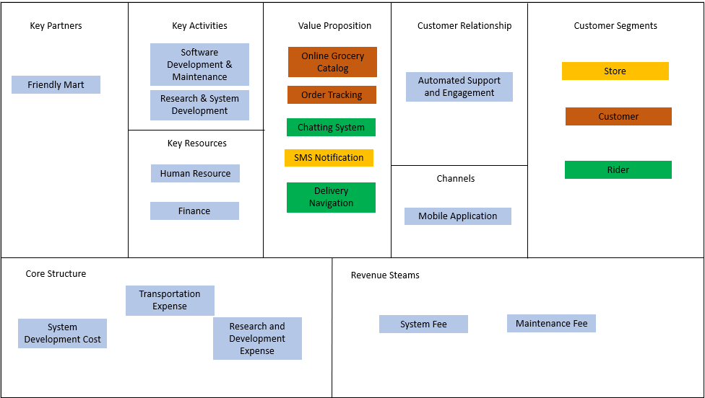

*Figure 3.2 Friendly Mart Ordering and Delivery Navigation with SMS Notification and Chatting System Business Model Canvas*

*This is the strategic management template for the development of the Friendly Mart Ordering and Delivery Navigation with SMS Notification and Chatting System. An overview layout of the system for and how it will run.*

**Gantt Chart** 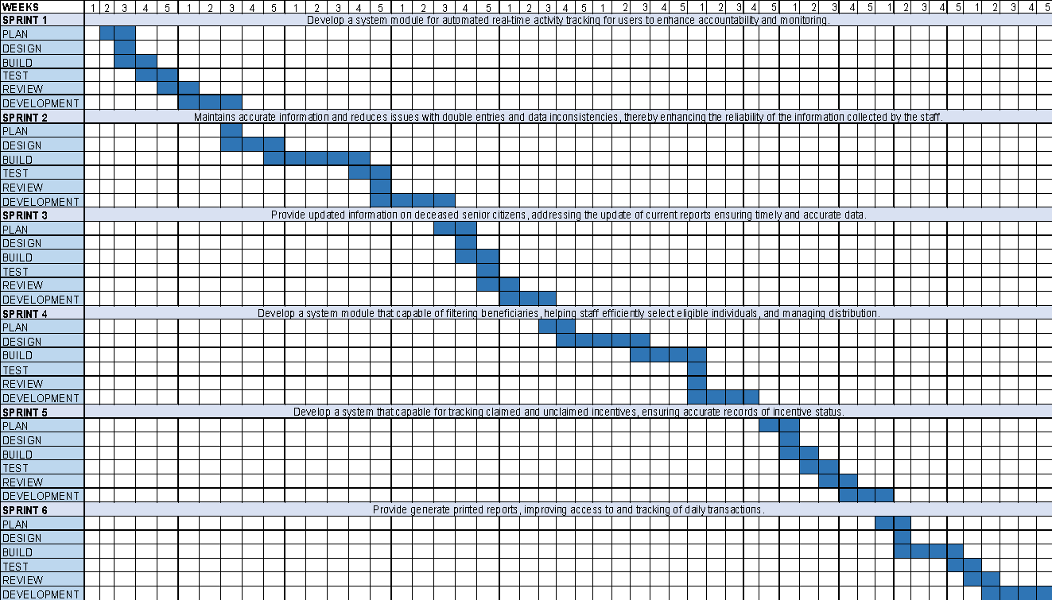

|  |  |
| --- | --- |
| **Legend** | **Color** |
| Finish |  |
| Ongoing |  |
| Unfinish |  |

*Table 3.1 Senior Citizen Management Support System Gantt Chart*

*This chart illustrates this capstone project schedule. This illustrates the start and ending week of the terminal element and summary element of the project. Terminal element and summary element comprise the work breakdown structure on the development of the monitoring system of SCMSS.*

**Functional Decomposition Diagram**

**FRIENDLY MART ORDERING AND DELIVERY NAVIGATION WITH SMS NOTIFICATION AND CHATTING SYSTEM**

Store

Inventory

Manage Product Inventory

Rider Application

Manage Rider Application

Customer

Order Tracking

View Order Delivery Progress

Grocery Catalog

View/Browsing Grocery Catalog

Rider

Chatting Module

Logs and View Messages

Delivery Navigation

View Customer Delivery Location

View real-time route direction

*Figure 3.3 Senior Citizen Management Support System Functional Decomposition Diagram*

*This diagram shows the breakdown of the monitoring and management system from the high-level function, processes, and organization down to the lower level.*

**Analysis-Design Phase**

**Use case Diagram**

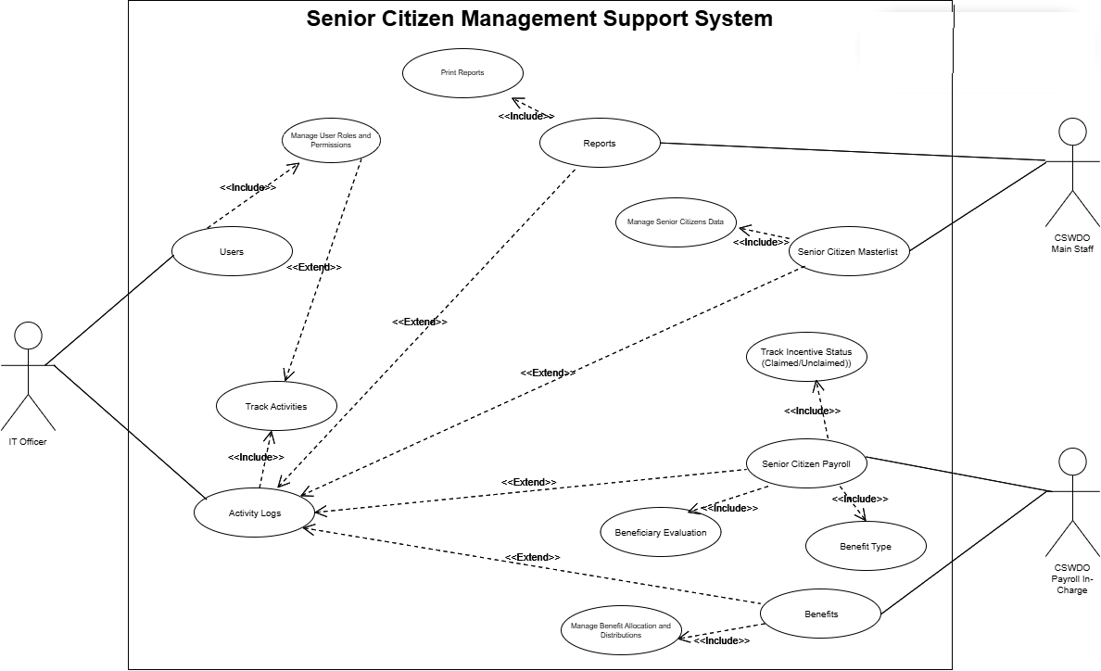

*Figure 3.4 Senior Citizen Management Support System Use Case Diagram.*

*This diagram shows the breakdown of the Senior Citizen Management Support System, detailing the roles and processes for managing user permissions, beneficiary data, payroll status, and benefit distribution across different organizational levels.*

**Use Case Matrix**

|  |  |
| --- | --- |
| GENERAL CHARACTERISTICS | |
| Intent | To identify the purpose of the features of the Senior Citizen Management Support System (SCMSS). |
| Scope | The scope of this use case matrix focuses on the CSWDO office and its staff, providing details of the functionalities they need to manage senior citizen data efficiently. |
| Level | Administrative |
| Author | Tracy Troy Bajos, Chemberlyn Crodua, Judie Bea Pamplona |
| Last Update | May 25, 2025 |
| Status | Completed |
| Primary Actor | (Admin/User) |
| Precondition | None |
| <Dynamic Precondition> | The admin must explore the system to familiarize themselves with all the functions and processes for running the system without encountering issues. |
| Assumptions | All the dynamic preconditions are already functioning successfully. |
| Triggers Event | Manage User  Manage Activity Log  Manage Master list  Manage Benefits  Manage Payroll  Manage Reports |
| Success Post Condition | After admin (IT Officer) created their account, the user can log into their accounts, and all system features and functions related to senior citizens’ data management and benefit processing are running successfully, addressing the identified issues. |
| Basic Flow | Admin/User logs into the system.  Selects the desired module (e.g., Manage Benefits, Manage Senior Citizen Information).  Performs the relevant action (e.g., input senior citizen data, distribute benefits).  The system validates the data and updates the records.  The system notifies confirmation of successful completion or prompts for corrections. |
| Failed Post Condition | SCMSS is still on process. |
| <Model> | Use Case Matrix |
| Operation Concepts | The **Senior Citizen Management Support System** automates the management of senior citizens’ data, the processing of benefits, tracking deceased citizens, filtering eligible beneficiaries, and generating reports. Admins manage senior citizen records, update statuses, and track benefits distribution. The system ensures security through role-based access control, maintaining integrity with regular backups and updates. By automating these processes, the system improves efficiency and reduces errors in managing senior citizen data. |
| Overview | The **use case approach** for the **Senior Citizen Management Support System** focuses on key interactions between actors such as the admin and system users. Admins manage senior citizens' data, process benefits, update statuses, and track incentives. This approach provides a clear, structured workflow that meets the needs of CSWDO staff in managing the senior citizen population efficiently and securely. |

*Table 3. 2: Senior Citizen Management Support System using Use Case Matrix*

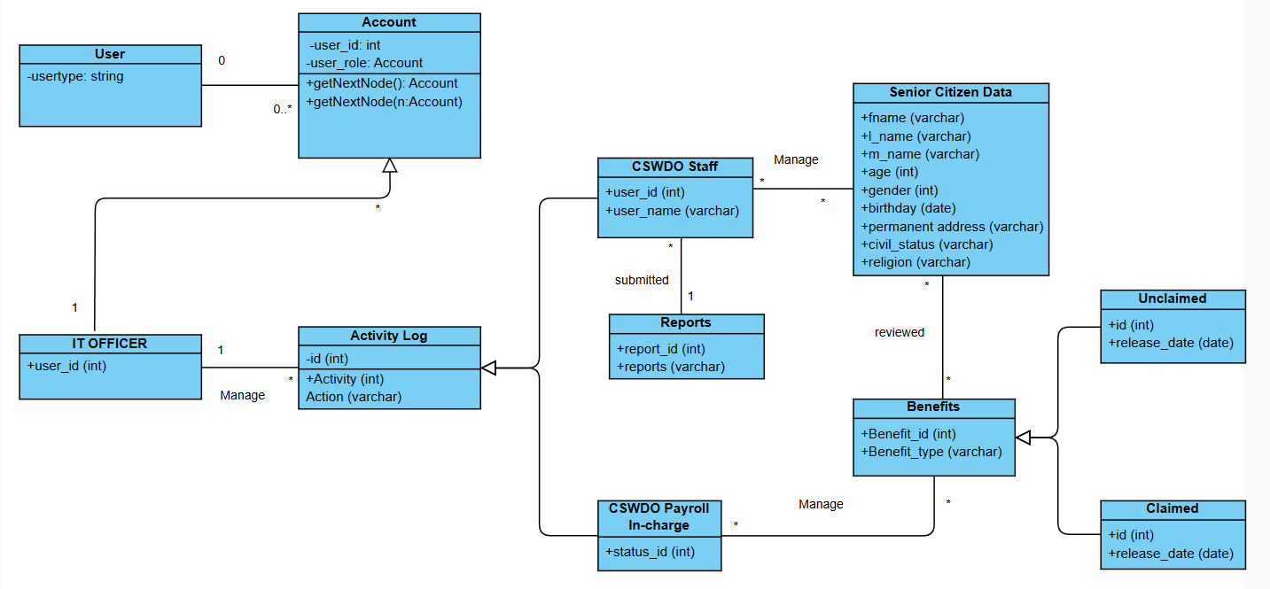

**Class Diagram**

*Figure 3. 5: The Class Diagram of Senior Citizen Management Support System*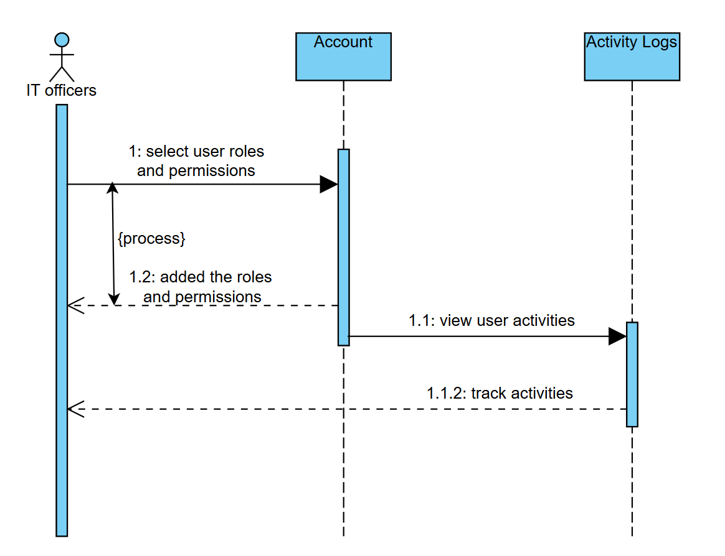

**Sequence Diagram (IT Officer)**

*Figure 3. 5.1: Senior Citizen Management Support System Sequence*

**Sequence Diagram (CSWDO Main Staff)**

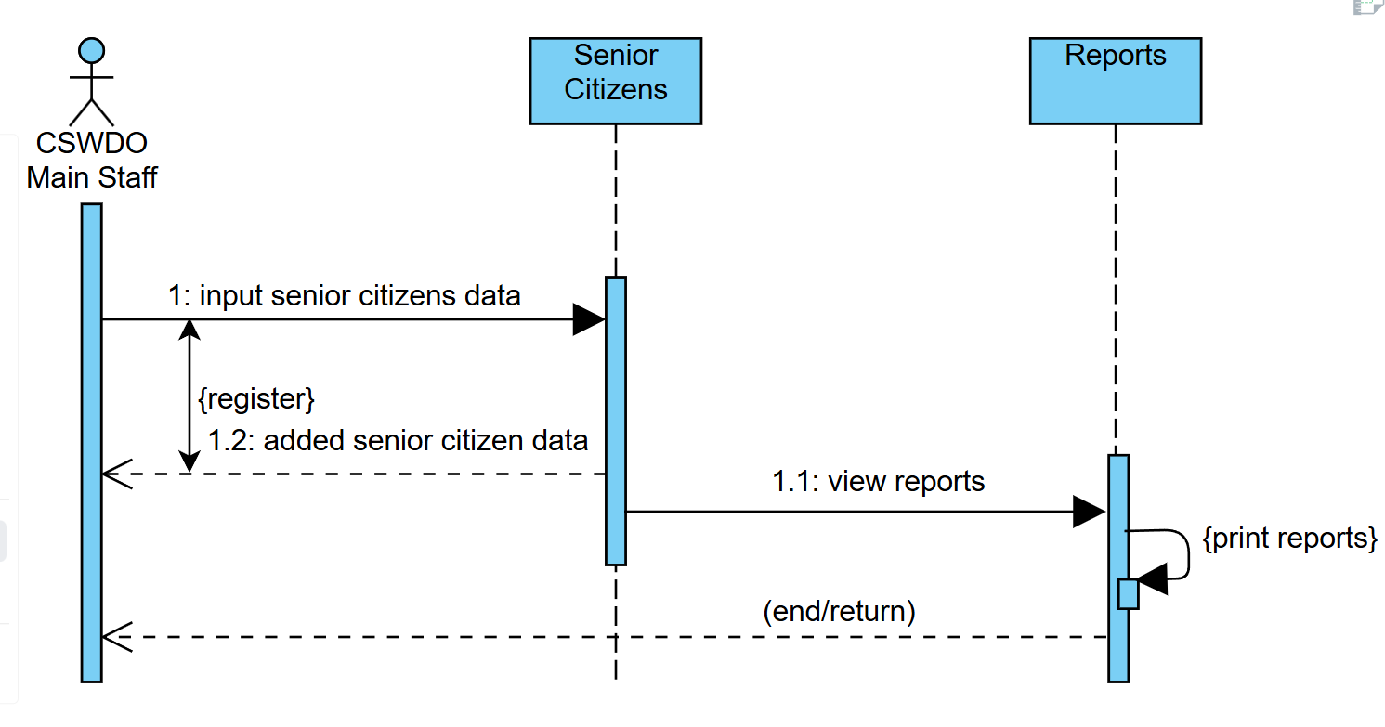

*Figure 3.5.2 CSWDO Main Staff Senior Citizen Management Support System Sequence Diagram*

**Sequence Diagram (Payroll in-charge)**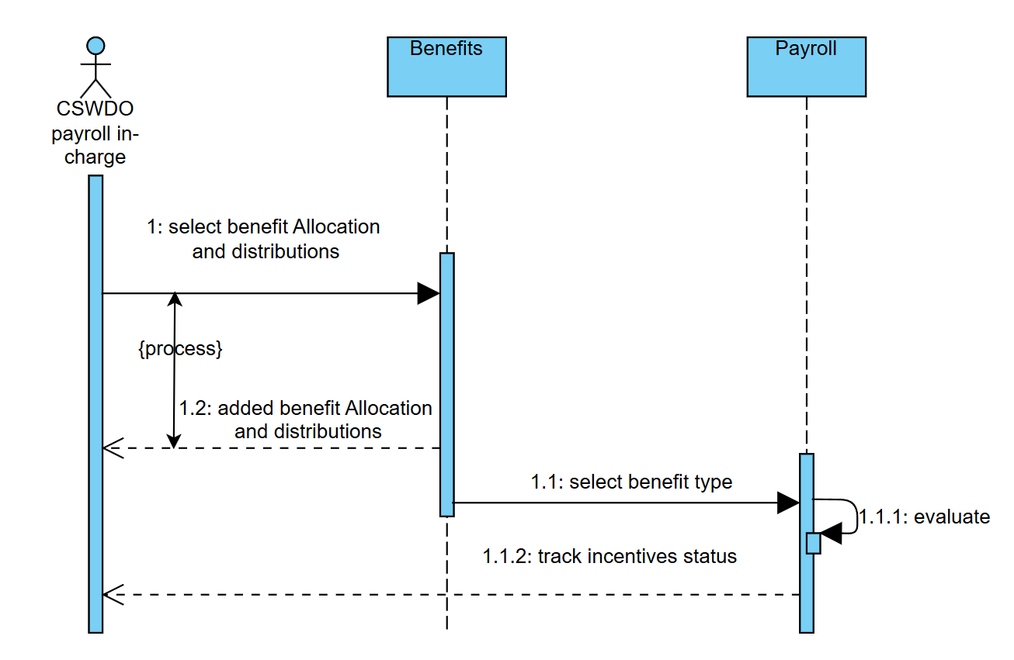

*Figure 3.5.3 CSWDO Payroll In-charge Senior Citizen Management Support System Sequence Diagram*

**Activity Diagram (IT Officer)**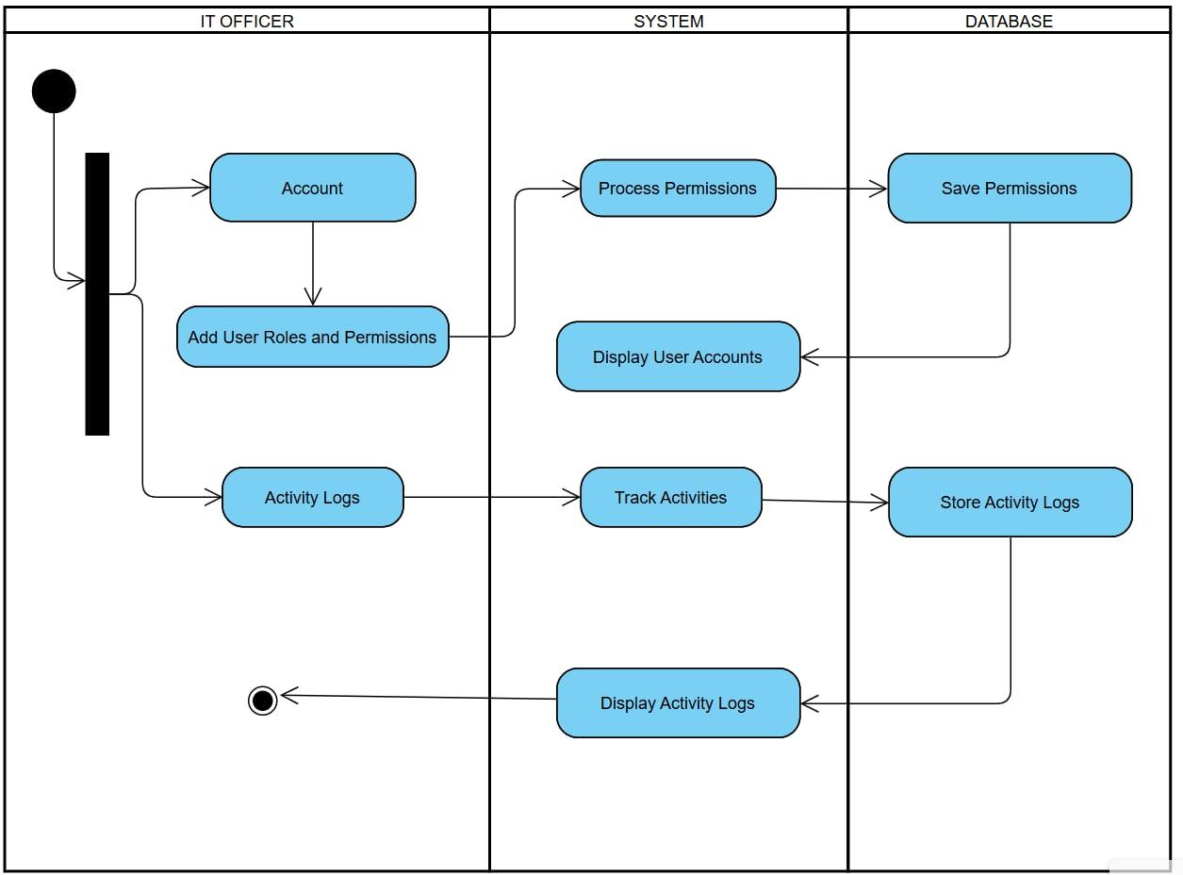

*Figure 3. 6.1: Senior Citizen Management Support System Activity Diagram for IT Officer*

**Activity Diagram (CSWDO Main Staff)**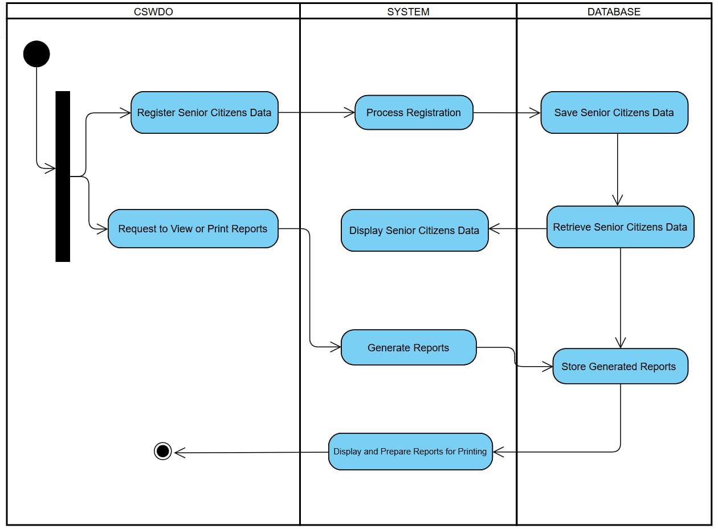

*Figure 3. 6.2: Senior Citizen Management Support System Activity Diagram for CSWDO Main Staff*

**Activity Diagram (Payroll in-charge)**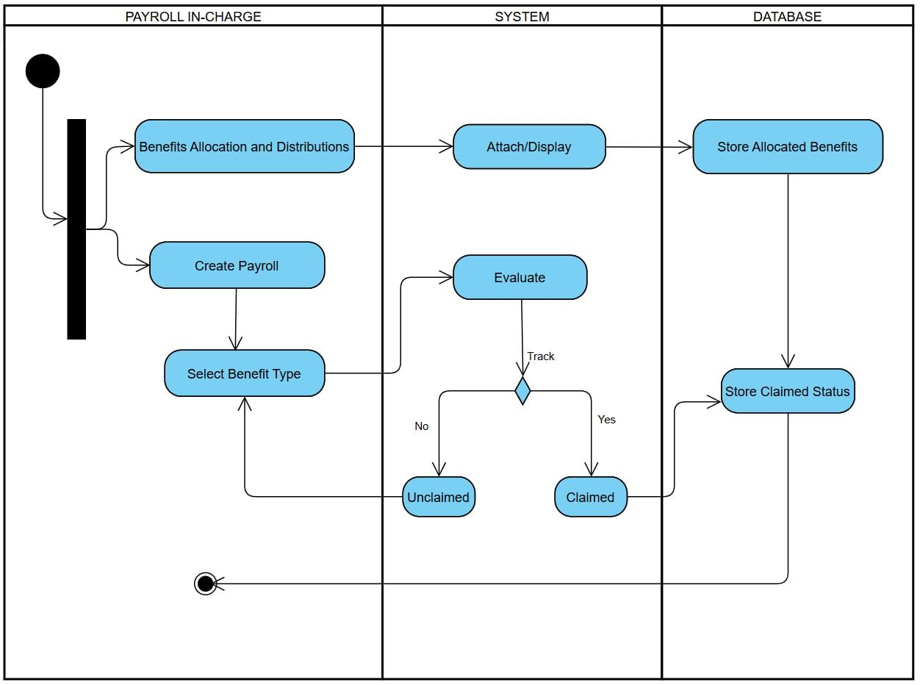

*Figure 3. 6.3: Senior Citizen Management Support Activity System Diagram for CSWDO Payroll in charge*

**User Interface Design**

**Storyboard** 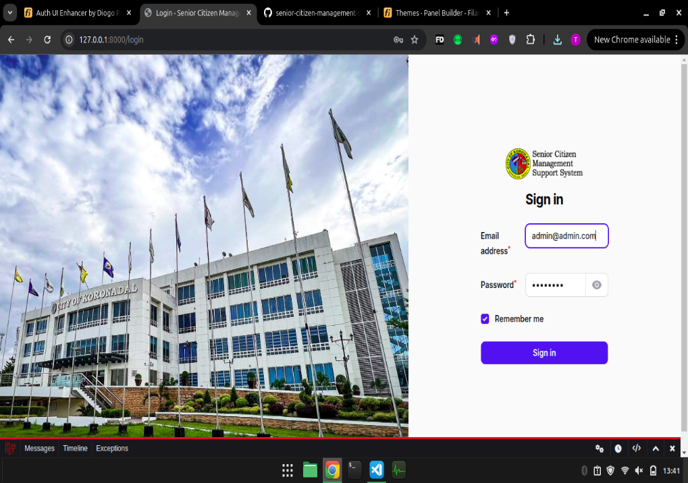

*Figure 3.7.1 Senior Citizen Management Support System Admin/User Log in Page*

*When the admin or user wants to access the Senior Citizen Management Support System (SCMSS), they are first directed to this log-in page using their credentials to gain access to the system's functionalities, ensuring security and authorized access.*

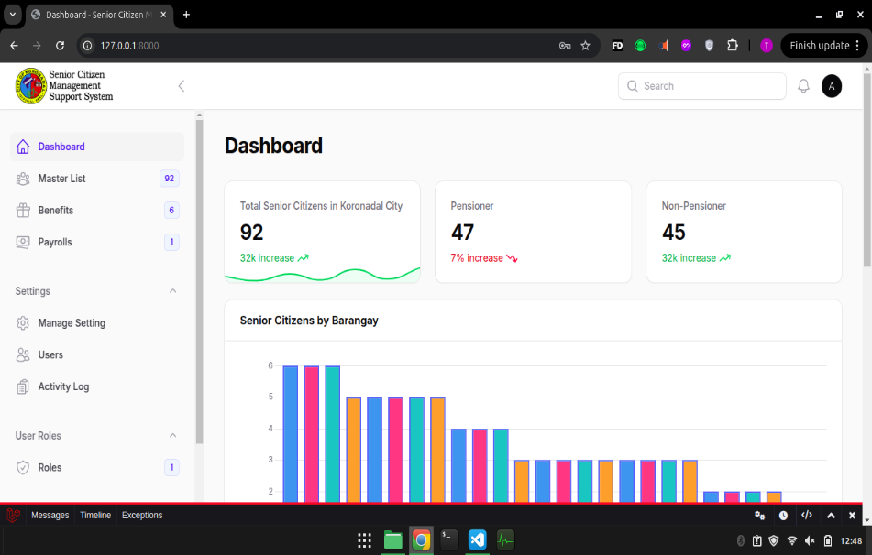



*Figure 3.7.2 Senior Citizen Management Support System Dashboard Page*

*The dashboard provides an overview and quick access to key modules like managing senior citizen data, benefits, and payroll, enabling efficient navigation.*

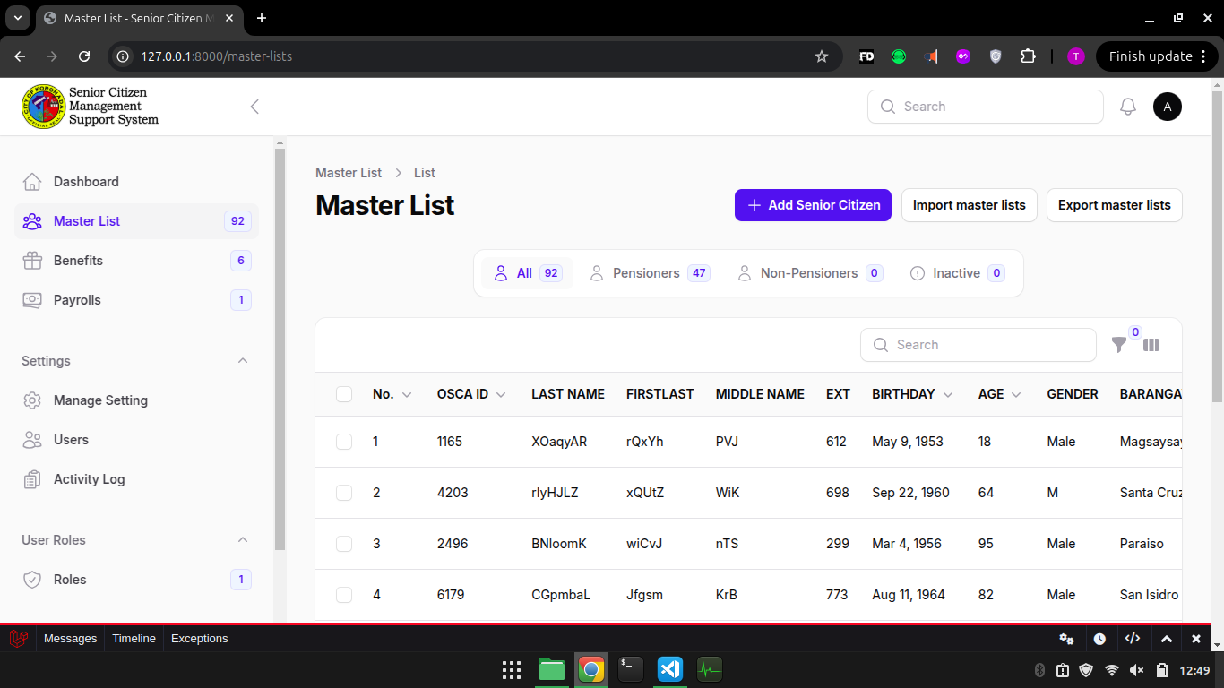

*Figure 3.7.3 Senior Citizen Management Support System Master list Page*

*This page allows users to view and update senior citizens' information, keeping records accurate and up-to-date.*

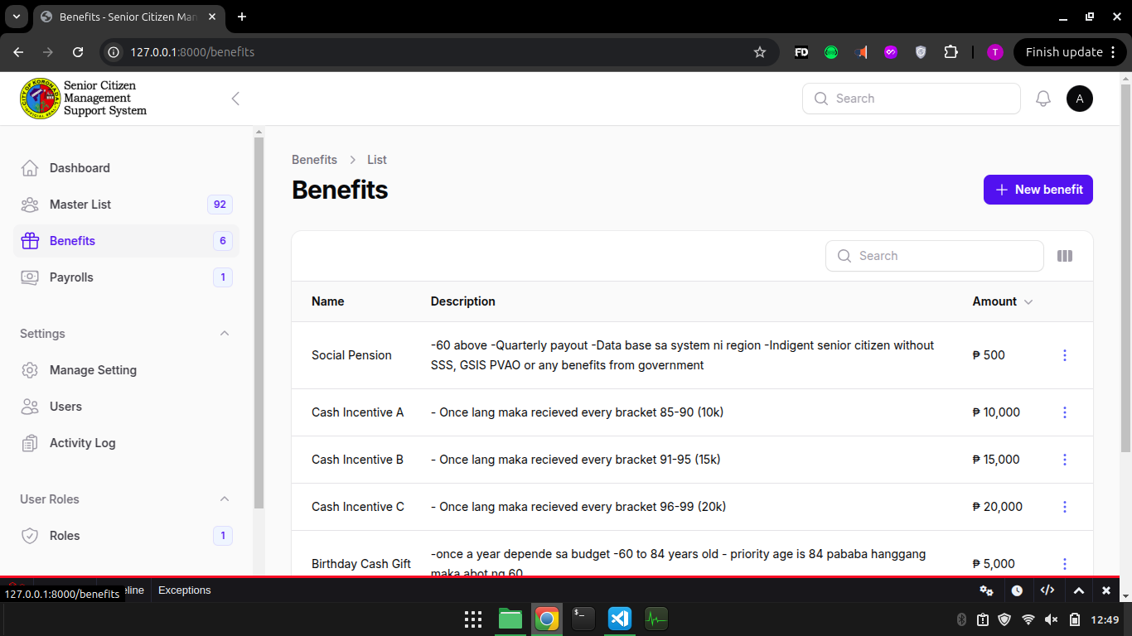

*Figure 3.7.4 Senior Citizen Management Support System Manage Benefits Page*

*This page allows the admin to manage various benefits available to senior citizens, such as social pensions and incentives. The admin can view all the existing benefits, modify them, or add new ones to ensure that all senior citizens receive the appropriate entitlements.*

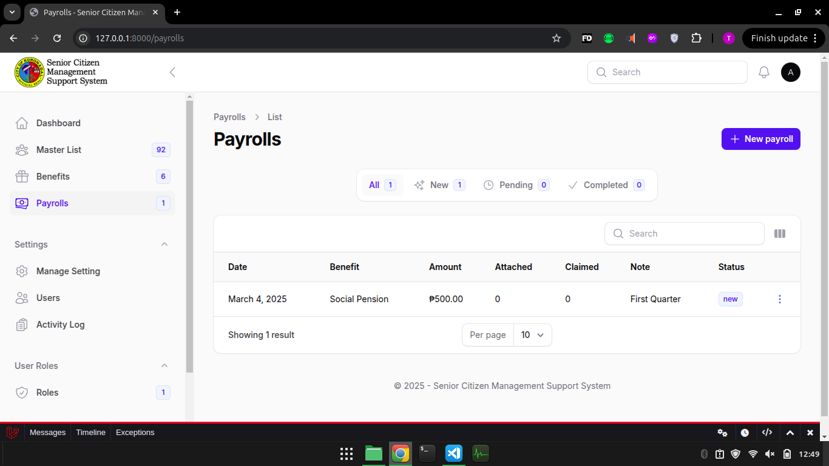

*Figure 3.7.5 Senior Citizen Management Support System Manage Payroll Page*

*The payroll page allows the admin to manage the disbursement of benefits to senior citizens. It tracks claimed and unclaimed incentives and helps the admin process payments. This feature ensures that benefits are distributed promptly and records are kept up to date.*

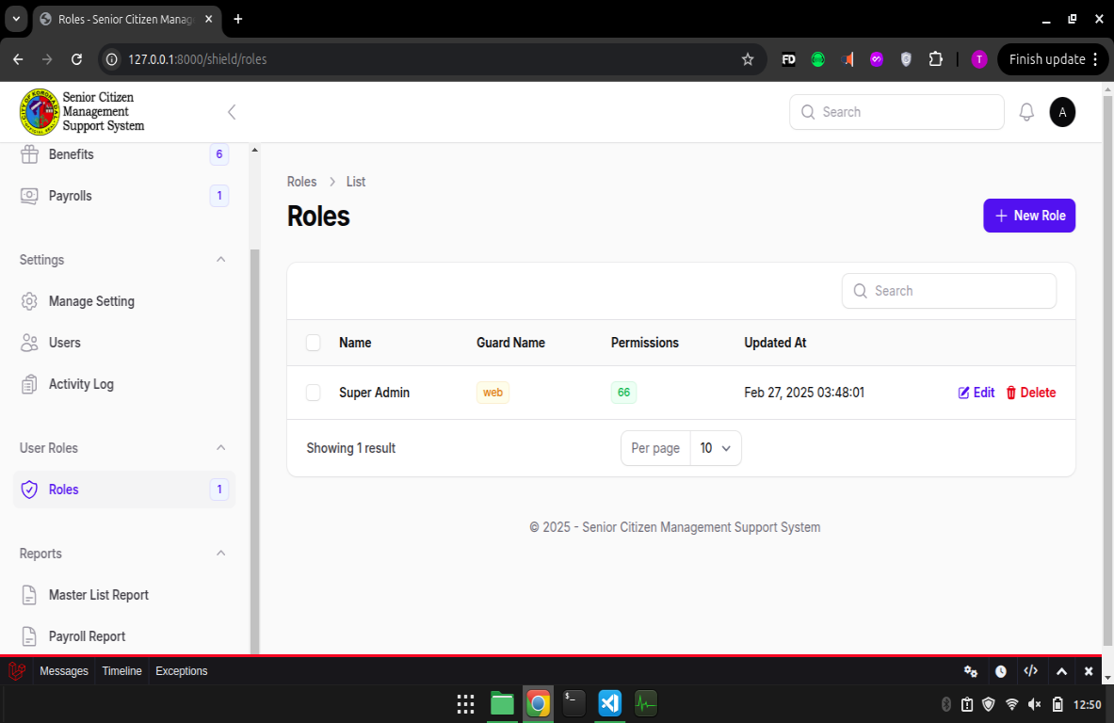

*Figure 3.7.6 Senior Citizen Management Support System Manage User Role Page*

*The Manage Role page enables IT officer to efficiently assign and manage roles for users, ensuring proper access control and streamlined task delegation.*

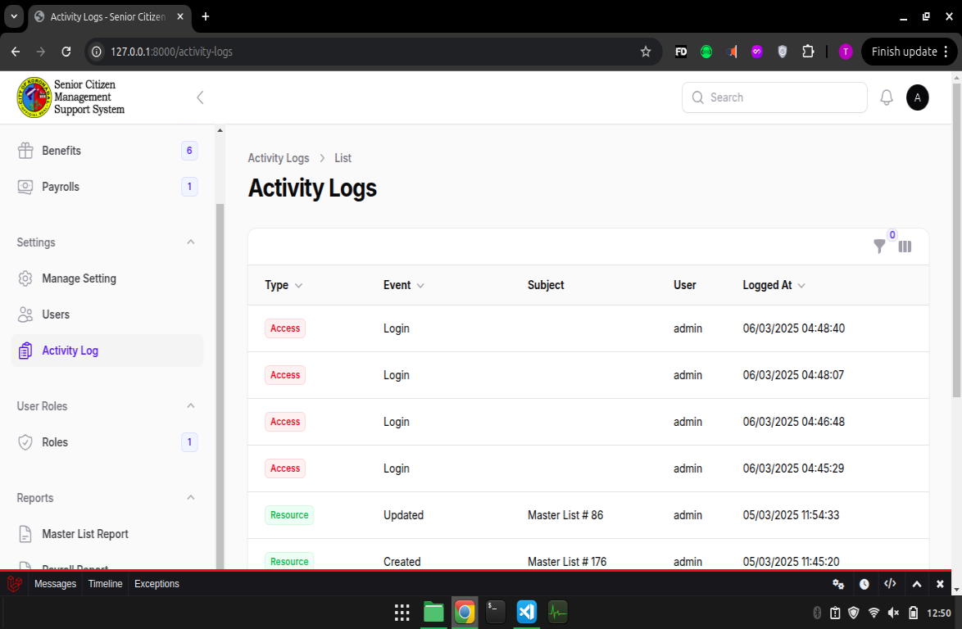

*Figure 3.7.7 Senior Citizen Management Support System Manage Activity Log Page*

*The activity log tracks all user actions within the system, ensuring transparency and accountability.*

**Forms**

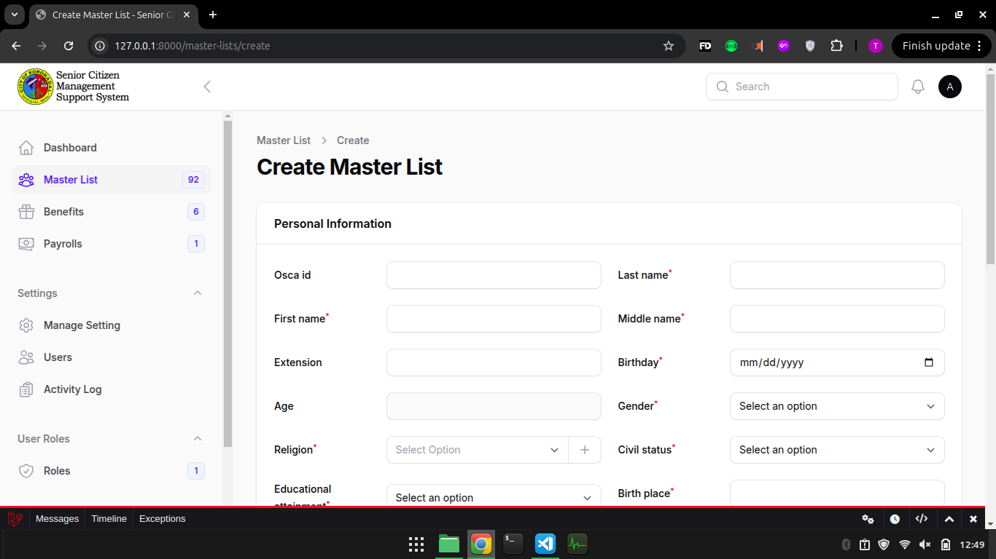

*Figure 3.8.1 Senior Citizen Management Support System Create Senior Citizen Page*

*On this page, the admin can input new data for a senior citizen, including personal details such as name, age, gender, and address.*



*Figure 3.8.2 Senior Citizen Management Support System Manage Create Type of Benefits Page*

*This page allows admins to create and define new types of benefits for senior citizens, ensuring relevant support is provided.*

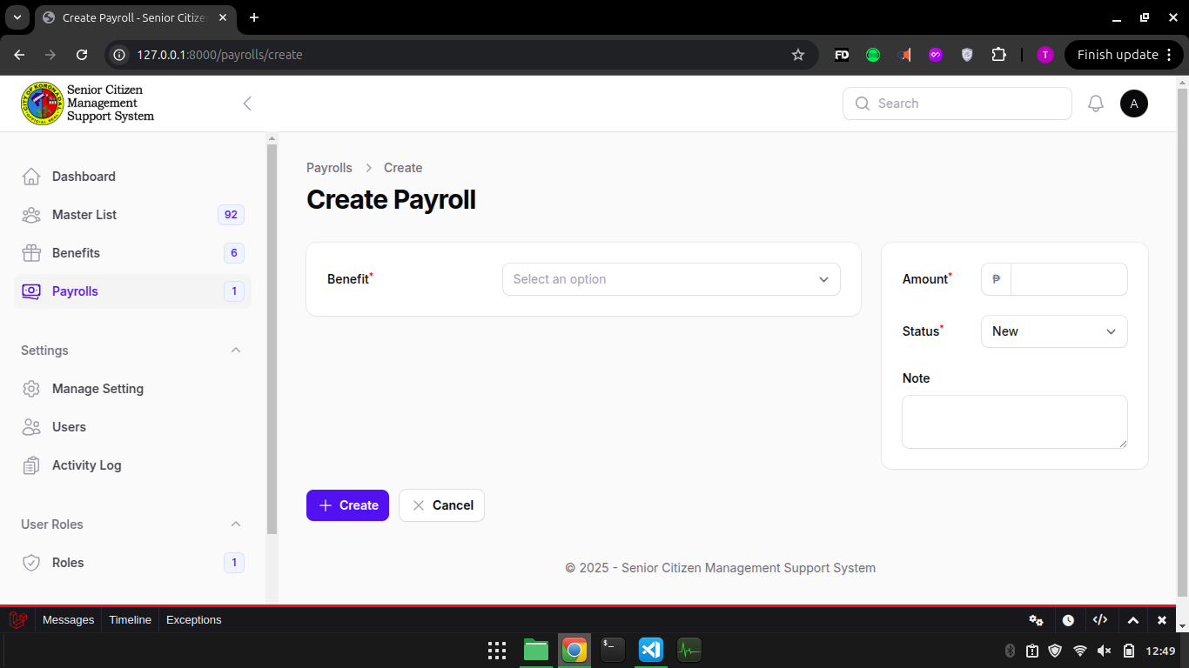

*Figure 3.8.3 Senior Citizen Management Support System Create Payroll Page*

*On this page, the admin creates a new payroll entry, which includes selecting the beneficiaries, the amount to be disbursed, and the date of payment.*

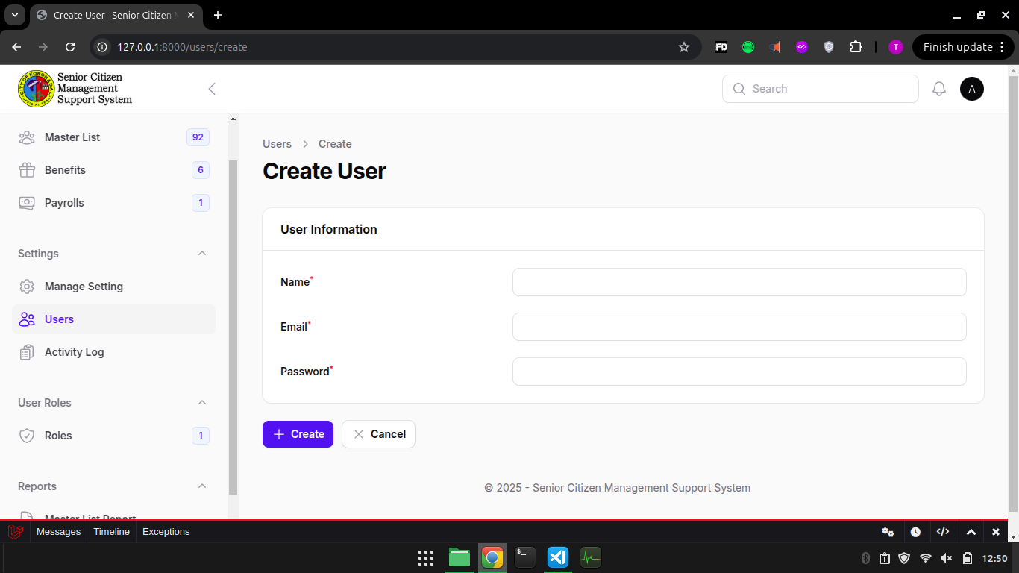

*Figure 3.8.4 Senior Citizen Management Support System Create User Page*

*On this page, IT Officer have the right to create new user accounts with assigned roles and permissions, ensuring controlled system access.*

**Reports**

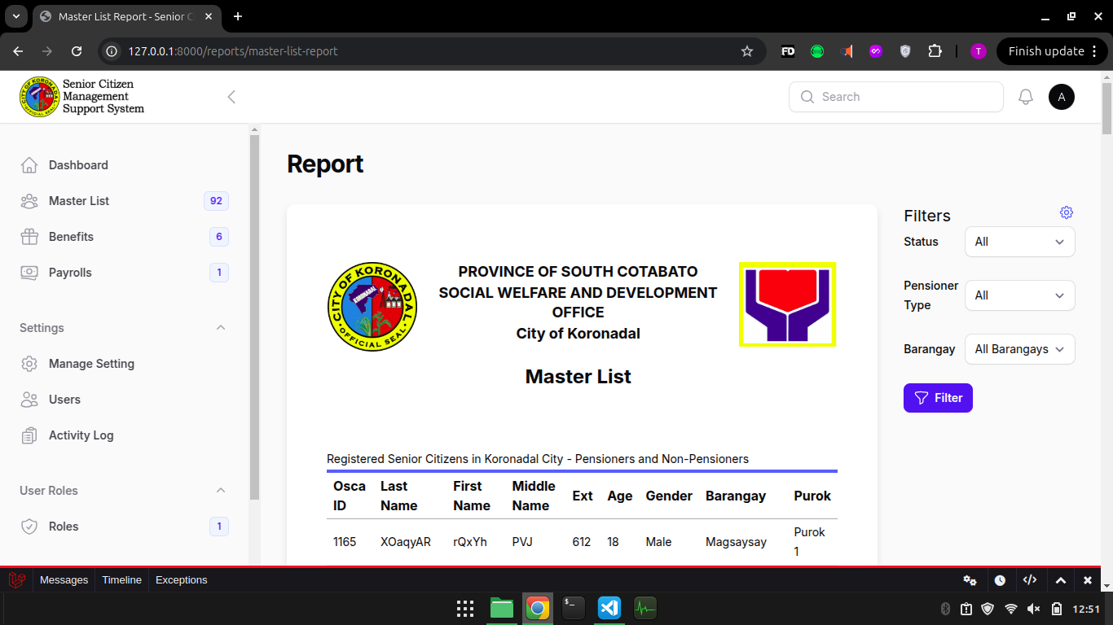

*Figure 3.9.1 Senior Citizen Management Support System Print Master List Report Page*

*The Print Master List Report page enables users to generate and print detailed reports for efficient documentation and access.*

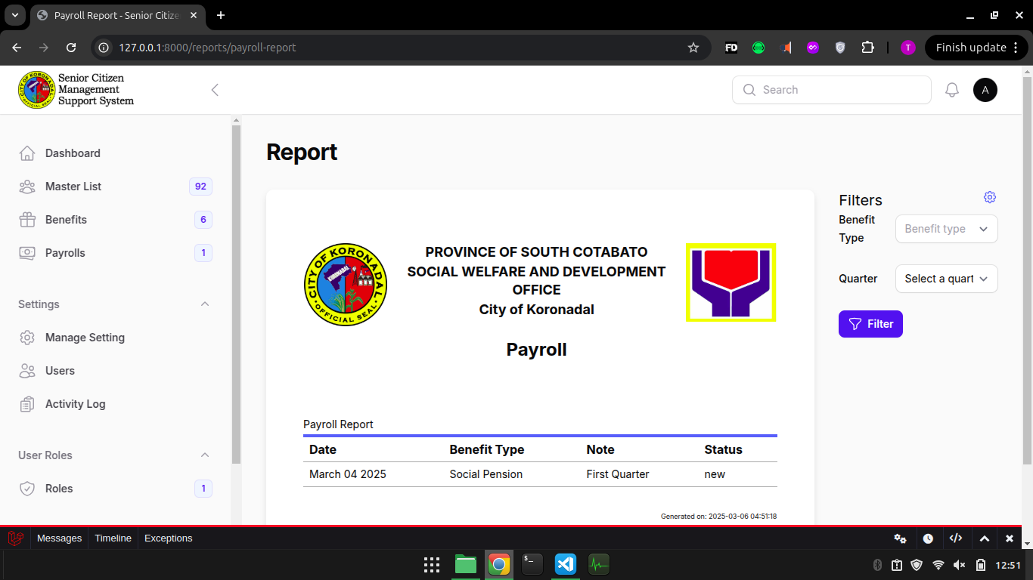

*Figure 3.9.2 Senior Citizen Management Support System Print Payroll Report Page*

*The Print Payroll Report page enables users to generate and print detailed reports for efficient documentation and access.*